**Повторення.**

**Ласкаво просимо до Києва.**

*31.05.2022 8А 8Б Хоменко А.Ю.*

**Мета:**

* розвивати навички діалогічного та монологічного мовлення за допомогою визуальних слайдів;
* Активизувати в мові учнів лексичні одиниці з теми;
* Виховувати любов та повагу до рідної країни та столиці держави.

1. **Warm up.**

Today we shall continue to speak about the capital of Ukraine Kyiv. You will learn new information about historical places and places of interest in Kyiv. Welcome to Ukraine! Welcome to this wonderful country! It has ancient culture and old history. Do you want to see it and know more about Ukraine?

1. **Reading and translating.**

I live in Ukraine. Ukraine appeared on the map of the world in 1991. Now Ukraine is a sovereign state with its own territory. It also has the national emblems: the state flag and the anthem. The state flag has two stripes on it. The stripes are blue and yellow. The blue colour means a blue sky and the yellow colour means a yellow field in summer.  
  
Ukraine is a sovereign state. Ukraine is situated in the east of Europe. Ukraine borders on Russia, Belarus, Poland, Moldova, Slovakia, Hungary, and Romania. It’s washed by the Black Sea and the Sea of Azov and has very important ports. Ukraine is larger than France and Great Britain. 5% of Ukraine’s territory is mountainous; the rest part of the Ukrainian area is flat. The Carpathians is the natural mountainous boundary of Ukraine. They are covered with mixed forests of pine, fir, beech and oak trees.

The Dnieper is the main river of the country; moreover, it’s the third longest river in Europe. Such rivers as the Dniester, the Danube, the Southern Bug and the Seversky Donets are also important.

Besides Ukrainians the representatives of many other nationalities live there: Russians, Jews, Belarusians, Moldavians, Romanians, Greeks, Tatars, Poles, Armenians, Germans and other ethnic minorities. They contributed to Ukraine’s culture and history.

The biggest cities of Ukraine are Kyiv, Kharkiv, Lviv, Dnipr, Zaporizhzhya, Odessa, Mykolaiv and others.

Ukraine is developed industrial and agricultural country. It’s rich in iron ore, coal, natural gas, oil, salt and other mineral resources. Ukraine has such branches of industry as metallurgy, machine-building, power industry, chemical industry and agriculture. Scientists of Ukraine make their contributions of important discoveries and inventions to the world science.

Ukraine has a rich historical and cultural heritage. There are many higher educational establishments, theatres, libraries, museums, art galleries in Ukraine. It’s also famous for many outstanding writers, poets and musicians.

Ukraine is a member of the United Nation Organization and takes part in the work of many international organizations.

1. **Writing**. (перегляньте визначні місця Києва)

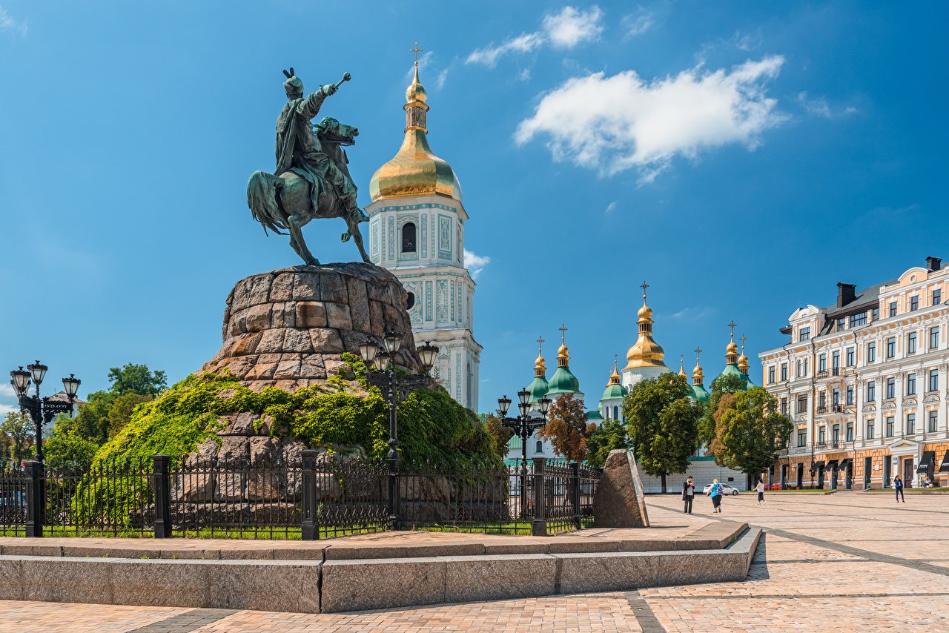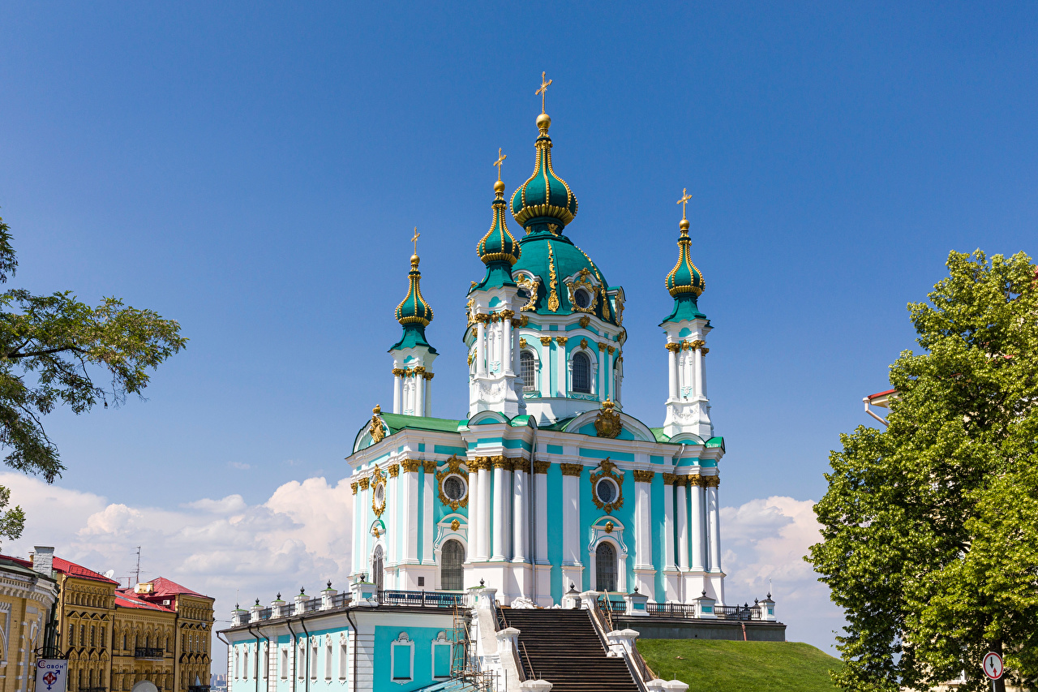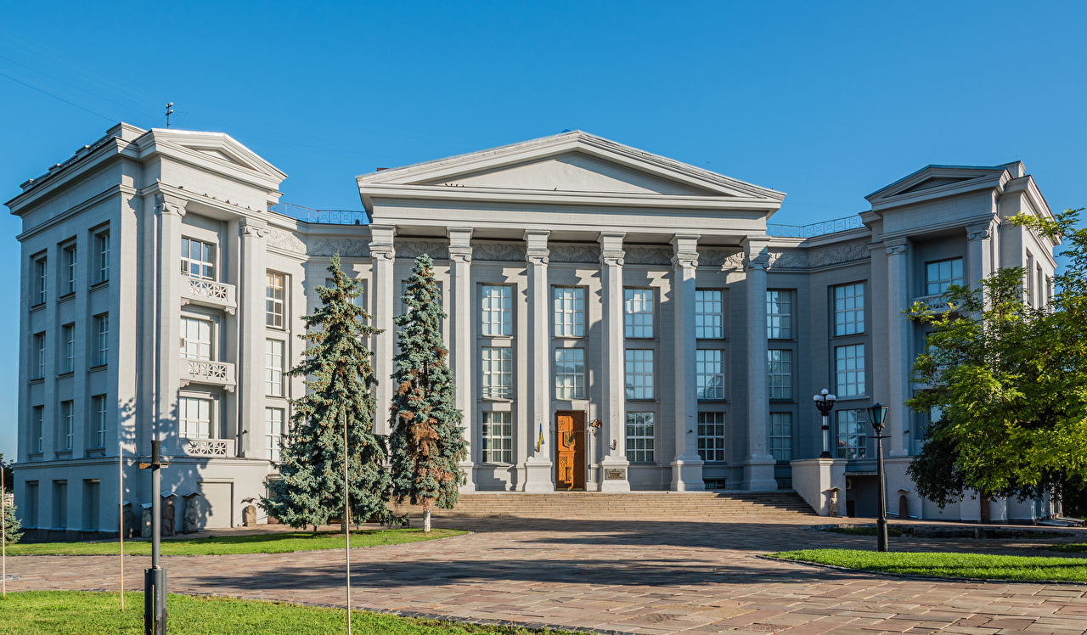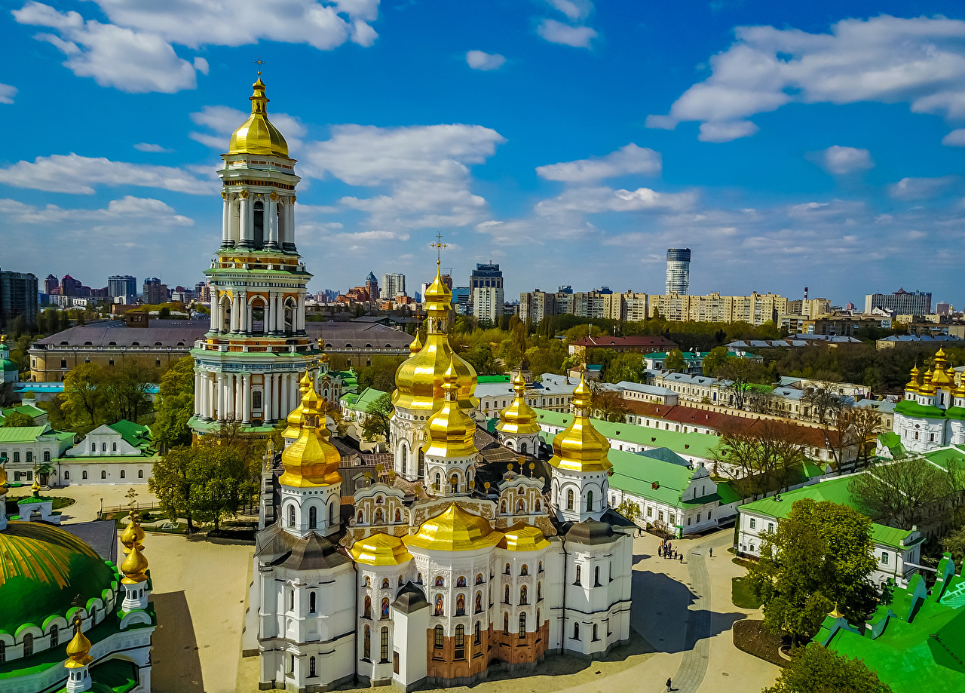

**Home work**: Шановні діти, вам необхідно

* Прочитати і перекласти текст
* Переглянути відомі місця Києва
* Повторити слова в словнику
* [Перегляньте презентацію](https://youtu.be/lAyWhJ6tr9E) з теми